**in this project, we present an innovative Smart Shoe Rack System that automates the process of shoe storage and retrieval. The system is designed to:**

* Scan barcodes attached to shoes, making it easy to identify and manage individual pairs.
* Send the scanned barcode data to a Google Sheets database for logging and tracking shoe usage.
* Utilize Blynk, an IoT platform, to allow remote control of the system. Users can effortlessly select which shoe to retrieve through a mobile application.
* The movement of the shoe rack is controlled by stepper motors that navigate in X, Y, and Z directions, ensuring the selected shoe is accurately retrieved and brought down to the user.

This smart system offers a more efficient, organized, and user-friendly way to manage personal footwear

在这个项目中，我们展示了一个创新的智能鞋架系统，该系统可以自动完成鞋子的存储和检索过程。该系统旨在：

扫描附在鞋子上的条形码，轻松识别和管理每双鞋子。

将扫描的条形码数据发送到 Google Sheets 数据库，以记录和跟踪鞋子的使用情况。

利用物联网平台 Blynk 实现对系统的远程控制。用户可以通过移动应用程序轻松选择要检索的鞋子。

鞋架的移动由步进电机控制，这些电机在 X、Y 和 Z 方向上导航，确保准确检索选定的鞋子并将其带给用户。

这个智能系统提供了一种更高效、更有条理、更用户友好的方式来管理个人鞋类.

**Traditional shoe cabinets have several limitations:**

* Limited storage capacity and inefficient space usage.
* Difficulty in sorting and retrieving shoes, especially by style, size, or color.
* Hygiene and safety concerns due to disorganized shoe placement, leading to potential falling hazards.
* Manual stock management in stores is time-consuming and error-prone, often resulting in inventory issues (overstock or out-of-stock).

Existing smart shoe cabinets are expensive with limited functionality, focusing mainly on basic automation like opening doors. They fail to address the need for a smart, customizable, and efficient shoe storage system.

This project aims to create a smart shoe rack that automatically selects, organizes, and tracks shoes, providing a space-optimized, user-friendly, and IoT-integrated solution.

传统鞋柜有几个局限性：

存储容量有限，空间利用率低。

难以对鞋子进行分类和检索，尤其是按款式、尺寸或颜色分类。

由于鞋子摆放杂乱无章，存在卫生和安全隐患，可能导致跌倒危险。

商店的手动库存管理既费时又容易出错，经常导致库存问题（库存过剩或缺货）。

现有的智能鞋柜价格昂贵，功能有限，主要侧重于开门等基本自动化。它们无法满足对智能、可定制和高效的鞋子存储系统的需求。

该项目旨在创建一个可以自动选择、组织和跟踪鞋子的智能鞋架，提供空间优化、用户友好且集成物联网的解决方案。

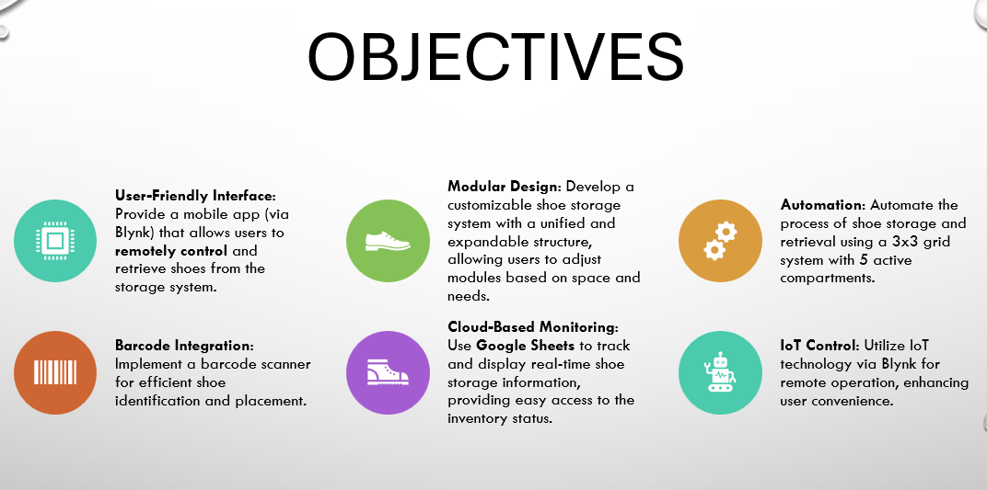

In summary, the **Smart Shoe Rack System** addresses the prevalent issues associated with traditional shoe storage solutions. By integrating advanced technology, this project provides :

* **Enhanced Organization**: The automated shoe retrieval and storage system effectively maximizes space and ensures easy access to shoes, minimizing clutter.
* **User Convenience**: With a user-friendly interface via Blynk, users can control the shoe rack remotely and retrieve their shoes effortlessly.
* **Efficient Inventory Management**: The integration of a barcode scanner and Google Sheets allows for accurate tracking and management of shoe inventory, reducing the likelihood of errors.
* **Customizable Design**: The modular structure of the shoe rack caters to diverse user needs, allowing for expansion and personalization based on available space.

Overall, this innovative solution not only improves the efficiency of shoe storage but also enhances user experience, making it an ideal choice for both households and retail environments. Future developments may include additional features like voice control and integration with other smart home devices, further elevating the functionality of the system.

总之，智能鞋架系统解决了传统鞋类存储解决方案中普遍存在的问题。通过集成先进技术，该项目提供：

增强组织性：自动鞋类检索和存储系统有效地最大化了空间，确保轻松取鞋，最大限度地减少杂乱。

用户便利性：通过 Blynk 的用户友好界面，用户可以远程控制鞋架并轻松取鞋。

高效的库存管理：条形码扫描仪和 Google 表格的集成可以准确跟踪和管理鞋类库存，降低出错的可能性。

可定制设计：鞋架的模块化结构可满足不同的用户需求，可根据可用空间进行扩展和个性化。

总体而言，这种创新解决方案不仅提高了鞋类存储的效率，还增强了用户体验，使其成为家庭和零售环境的理想选择。未来的发展可能包括语音控制和与其他智能家居设备的集成等附加功能，从而进一步提升系统的功能。

* **Advanced Drivers**: Use improved motor drivers for better performance.
* **Camera Integration**: Add a camera for automatic compartment location.
* **Upgraded Motors**: Implement high-quality stepper motors for reliability.
* **Better Rails**: Utilize superior rails for smoother and quieter operation.
* **Expanded Capacity**: Design for a larger grid to hold more shoes.
* **Enhanced Barcode Scanner**: Improve scanner accuracy for quicker identification.
* **Voice Control**: Integrate voice control for hands-free operation.
* **Commercial Applications**: Explore uses in smart homes and retail environments.

高级驱动器：使用改进的电机驱动器以获得更好的性能。

摄像头集成：添加摄像头以实现自动隔间定位。

升级的电机：采用高质量的步进电机以提高可靠性。

更好的导轨：利用优质导轨实现更平稳、更安静的操作。

扩大容量：设计更大的网格以容纳更多的鞋子。

增强的条形码扫描仪：提高扫描仪的准确性，以便更快地进行识别。

语音控制：集成语音控制以实现免提操作。

商业应用：探索在智能家居和零售环境中的用途。